**Transfer function of Amplifier**

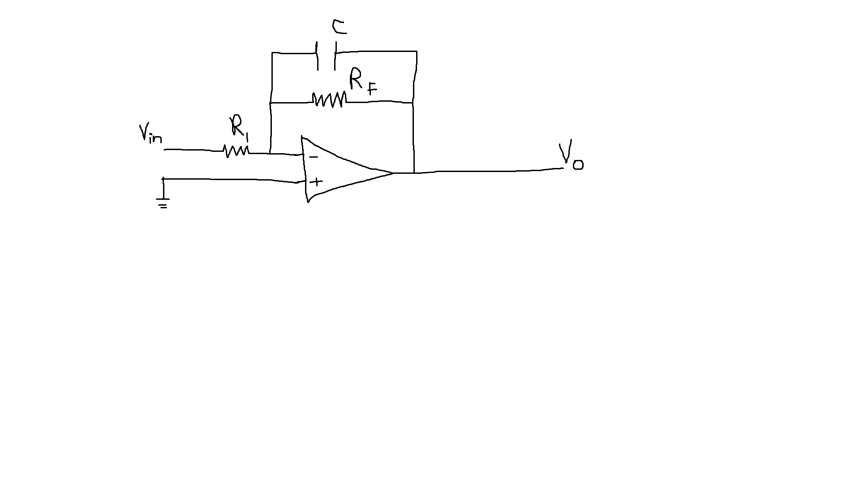

$$Vout\left(t\right)=Vin\left(t\right)$$

Using KCL,

$$\frac{Vin(t)-0}{R_{1}}=\frac{0-Vout\left(t\right)}{R_{f}}+C\frac{ d(0-Vout\left(t\right))}{dt}$$

$$\frac{Vin(t)}{R_{1}}=\frac{-Vout\left(t\right)}{R_{f}}-C\frac{ d(Vout\left(t\right))}{dt}$$

Using Laplace,

$$\frac{Vin(s)}{R_{1}}=\frac{-Vo\left(s\right)}{R_{f}}-C.S. Vout(S)$$

$$\frac{Vin(s)}{R_{1}}=-Vo\left(s\right)\frac{(1+C.S.R_{f})}{R_{f}}$$

$$\frac{Vin(s)}{R_{1}}=-Vo\left(s\right)\frac{(1+C.S.R_{f})}{R_{f}}$$

$$\frac{Vo\left(s\right)}{Vin(s)}=\frac{{-R}_{f}}{R_{1}.(1+R_{f}C.S)}$$

**Amplifier**

$$R_{f}=10kΩ$$

$$R_{1}=10kΩ$$

C=680nF

$$\frac{Vo\left(s\right)}{Vin(s)}=\frac{1}{(1+68×{10}^{-5}S)}$$

$$m_{p}=e^{(\frac{-ξπ}{\sqrt{1-ξ^{2}}})}$$

$$0.1=e^{(\frac{-ξπ}{\sqrt{1-ξ^{2}}})}$$

$$-2.304=\frac{-ξπ}{\sqrt{1-ξ^{2}}} \\ 5.308=\frac{ξ^{2}π^{2}}{1-ξ^{2}}$$

$$ξ=0.59$$

$$ω_{n}=\frac{1.74}{0.59}$$

$$ω_{n}=2.95 {rads}^{-1}$$